Brightspace has a calendar tool which is automatically populated with virtual classroom sessions you schedule in either Bongo or Webex as well as assessments that have a due date. In addition to those automatic events, you can also create your own custom events.
You as well as students can see the calendars for all modules / units / courses no matter which module / unit / course you or students are in. In addition, the calendar(s) can be added to your UHI mailbox calendar. Follow the steps below to find out how to get a link to a calendar in Brightspace as well as how to add it to Outlook.

Step 1 – Getting a link to a calendar in Brightspace
On a module / unit / course homepage, scroll down to the calendar widget which is located underneath the Visual Table of Contents (TOC). If there are already virtual classroom sessions scheduled, or if there are any assessments with due dates, you will already see them as upcoming events.
Click on the drop-down menu at the top of the widget and select Subscribe from the drop-down menu (Figure 1).

Figure 1: Calendar tool with drop-down menu and option to subscribe

A pop-up window will open. You will see a drop-down menu at the top giving you the choice to export All Calendars and Tasks, you can choose to export Tasks Only, or you can choose to export a calendar for a particular module / unit / course. For this example, we will export the calendar for one particular module called “UHI Benchmarks”.
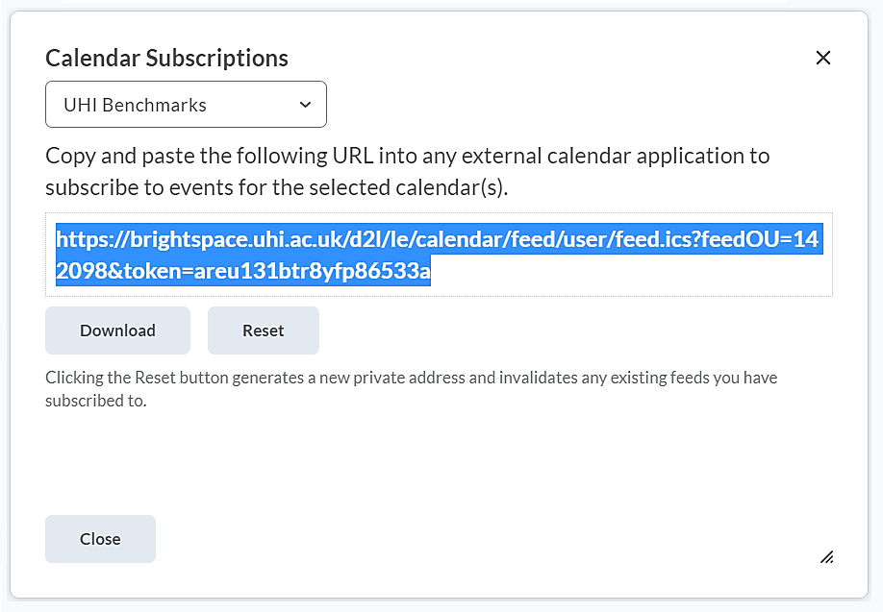
Once you have made your selection, highlight the URL for the calendar and copy it (Figure 2). You can do this by right-clicking on the highlighted URL and selecting Copy from the menu that will open. Alternatively, you can use the short key combination Ctrl + C once you have highlighted the link.

Figure 2: Calendar Subscriptions pop-up window with option to select a calendar and copy the link to the calendar

Step 2 – Adding the Brightspace calendar to Outlook using the URL you just copied
Next, go to your Outlook mailbox. You can either open your UHI mailbox via https://webmail.uhi.ac.uk or via the Outlook desktop app if you have it installed on your device. Once you are in your UHI mailbox, navigate to the calendar feature.

If you are using the Outlook web service…
Once the calendar has opened, find the Add calendar option in the left-hand side menu next to the calendar and click on it. A pop-up window will open. From the left-hand side menu, select Subscribe from web. You can now paste the URL you copied before into the space provide (Figure 3). Once again, you can either paste by right-clicking into the space and selecting Paste from the menu that will open, or you can use the short key combination Ctrl + V.
Figure 3: Add calendar option on the left and pop-up window with option to subscribe to a calendar from the web

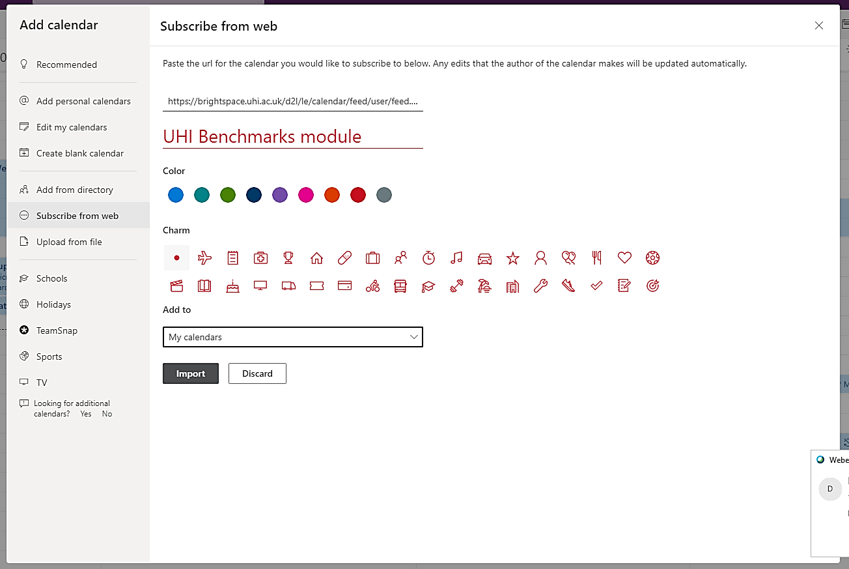
You can now give the calendar a name and assign a colour as well as an icon if you would like to do so. As you might have different sets of calendars, you can also choose the set you would like to add it to, in this case My calendars. When you are done, click on the Import button at the bottom of the screen (Figure 4).
Figure 4: Subscribe to calendar from web pop-up window with option to enter a name, customise the colour and add the calendar to a particular set of Outlook calendars
You will now see that your calendar has been added to your list of calendars and that any existing events are displaying in the calendar.

If you are using the Outlook desktop app….
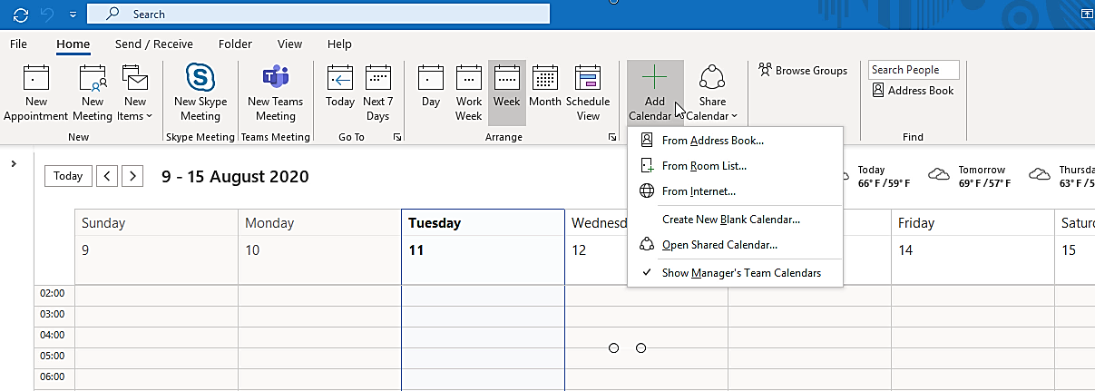
Once your calendar in the Outlook desktop app has opened, find the Add calendar option at the top of the window and click on it. A drop-down menu will open. Select From Internet (Figure 5).
Figure 5: Outlook calendar in the Outlook desktop app with option to Add Calendar From Internet
This will open a pop-up window. You can now paste the URL you copied before into the space provide. Once again, you can either paste by right-clicking into the space and selecting Paste from the menu that will open, or you can use the short key combination Ctrl + V. Click OK (Figure 6).

Figure 6: Box for pasting in the calendar link and OK button
You will now be asked whether you want to add the calendar to Outlook and subscribe to updates. Select Yes (Figure 7).
Figure 7: Option to subscribe to calendar updates with Yes button

The calendar has now been added to the My Calendar set in Outlook.
Note:
Once the calendar has been added, any updates made in Brightspace, i.e. any new virtual classroom sessions, assessment deadlines and other events will be synched into your Outlook version of the calendar automatically.
It is important to note that this synching process can take up to 24 hours.

